

Design and Implementation of an Automated Threat Detection and Response System in AWS

Module code: CIS4055

Module Title: Computing Masters Project
Module Leader: Dr. Zia Ush Shamszaman
Module Supervisor: Golightly, Lewis

BY
RAM KUMAR BENDALAM
S3206783

Contents
Abstract 4
1. Introduction 5
1.1 Research Motivations 5
1.2 Research Contributions 6
2. Literature Review 6
3. Methodology 7
3.1. Design of Secure Cloud Network Architecture 8
3.2. Implementation of Monitoring and Visibility Controls 8
3.3. Automated Threat Detection and Response Integration 9
3.3.1 GuardDuty Threat Detection 9
3.3.2 EventBridge Rule Configuration 10
3.3.3 Lambda Remediation Workflow 10
3.4. Testing, Validation and Evaluation 11
4. Architecture 12
4.1. Network Layer 13
4.2. Monitoring and Detection Layer 13
4.3. Automation and Response Layer 14
4.4. Centralised Visibility and Reporting Layer 14
5. Sequence Diagram 15
5.1 Workflow Overview 15
5.2 Step-by-Step Sequence Description 16
Step 1: Detection of suspicious activity by GuardDuty 16
Step 2: GuardDuty publishes the finding as an event 16
Step 3: EventBridge evaluates the event and triggers automation 16
Step 4: Lambda executes quarantine logic on the EC2 instance 16
Step 5a: Response actions are recorded in CloudWatch Logs 16
Step 5b: Security status is updated in Security Hub 16
6. Implementation 17
6.1 Cloud Environment setup 17
VPC Configuration 18
6.2 Internet Gateway and NAT Gateway Configuration 19
6.3 EC2 Instance Deployment 21
6.4 Threat Detection using Amazon Guard Duty 22
6.5 Monitoring, logging and Alerts 25
7. Performance Evaluation 27
7.1 Evaluation Metrics 27
7.2 Analysis 27
7.2.1 EC2 CPU Utilisation 28
7.2.2 Lambda Execution Duration 28
8. Iterations 29
Network & Visibility 29
8.1 VPC Flow Logs 29
9. List of Abbreviations 30
References: 30

Abstract
Cloud infrastructures are increasingly vulnerable to complex and rapidly evolving cyber threats, making automated security systems crucial for maintaining resilience and reducing incident response times. This project demonstrates the design and implementation of an automated threat detection and response system within an Amazon Web Services (AWS) environment. The seamless integration of three essential AWS
EventBridge then executes a custom Lambda function that provides quick remediation, including isolating the compromised EC2 instance by deleting its public IP, adding a quarantine security group, and flagging the resource for further investigation.
The speed and consistency of incident response are significantly enhanced by this automated approach, which also minimises human involvement. Supporting components, such as VPC Flow Logs, CloudTrail, Security Hub, and IAM policies, enable additional layers of monitoring, auditing, and compliance, thereby improving the overall security posture. The system serves as an example of how cloud-native services can be combined to build an autonomous, scalable, and adaptable defence system. The resulting architecture lays the groundwork for further predictive research and provides a viable solution for businesses seeking to enhance cloud security through automation.
Keywords: AWS Security, Guard Duty, EventBridge, Lambda Automation, Cloud Threat Detection, Incident Response, Cloud Architecture

Introduction
Cloud computing has quickly become a central part of how organisations build and deliver digital services, offering the ability to scale quickly and operate more efficiently than ever before. However, as businesses move more of their critical systems into the cloud, the security risks they face have also evolved. Cyberattacks are becoming more sophisticated, and even small misconfigurations can expose systems to serious threats. This growing complexity means that relying only on manual security processes is no longer enough to keep cloud environments safe.
This project explores how a secure cloud network can be designed in Amazon Web Services (AWS) and strengthened through automated threat detection and response. The aim is not just to build a secure network, but to show how AWS-native security tools can work together to respond to threats instantly and without human intervention. Using services such as Amazon GuardDuty, VPC Flow Logs, CloudTrail, and Security Hub for visibility, and integrating EventBridge with AWS Lambda for automation, the project demonstrates how cloud environments can actively defend themselves. This approach reflects a modern shift towards intelligent, self-healing security systems in the cloud.

1.1 Research Motivations
- Increasing cloud adoption and expanding attack surfaces, which require organisations to deploy secure, resilient, and self-defending cloud infrastructures.
- The growing sophistication of cyberattacks, where misconfigurations, weak visibility, and slow response times remain leading causes of cloud compromises.
- The need for automated security operations, reducing reliance on manual processes by integrating threat detection, monitoring, and remediation within AWS-native services.
- The opportunity to demonstrate cloud-native tools such as GuardDuty, CloudTrail, VPC Flow Logs, and EventBridge can be orchestrated to form an autonomous incident-response workflow.
- The growing business requirement for intelligent defence mechanisms, enabling systems to isolate threats rapidly, minimise human intervention, and maintain operational continuity.

1.2 Research Contributions
This project contributes to cloud security research by demonstrating how AWS-native services can be combined to create a secure, intelligent, and automated defence system. While secure cloud architectures are widely discussed, there is still a gap in practical implementations that integrate detection, monitoring, and automated response into a single, cohesive workflow. This project addresses that gap by showing how AWS tools can be orchestrated to improve visibility, reduce human dependency, and enhance real-time protection. The contributions of this work are summarised below as three key achievements:
• A secure multi-tier AWS network architecture using VPC segmentation, controlled access, and defence-in-depth principles.
• An integrated monitoring and threat-visibility layer using VPC Flow Logs, CloudTrail, GuardDuty, and Security Hub.
• An automated threat detection and response workflow using GuardDuty, EventBridge, and Lambda to isolate compromised EC2 instances in real time.
Together, these contributions show how cloud-native security features can be used not only to detect threats but also to respond automatically, reducing risk exposure and strengthening overall cloud resilience.

2. Literature Review
Cloud security has become a major focus in both academic research and industry practice due to the rapid growth of cloud adoption and the rise of sophisticated cyber threats. As organisations increasingly rely on cloud platforms like AWS, researchers highlight that misconfigurations, delayed incident response, and lack of visibility remain the leading causes of cloud compromises (Hashizume et al., 2013). This reinforces the importance of secure network design and continuous monitoring as foundational elements in cloud security strategies.
Virtual Private Cloud (VPC) segmentation, multi-tier architectures, and least-privilege access controls are repeatedly recommended in literature to minimise attack surfaces (Krutz & Vines, 2010). Logging and monitoring tools such as AWS CloudTrail and VPC Flow Logs are widely recognised as essential components for auditing cloud activity and detecting anomalies (Sartor et al., 2020). These services provide the raw data required to identify suspicious patterns, yet research suggests that organisations often struggle to respond quickly to detected threats due to reliance on manual processes.
Amazon GuardDuty has gained attention for its ability to perform intelligent threat detection using machine learning and threat intelligence feeds (Liu et al., 2022). While GuardDuty provides strong detection capabilities, studies indicate a gap between detection and response, with many environments failing to remediate threats in real time. Recent literature calls for automated, event-driven security workflows that reduce response times and improve cloud resilience.
This project directly addresses that gap by integrating GuardDuty with EventBridge and Lambda to create a self-acting remediation system, demonstrating how cloud-native automation can strengthen operational security and reduce human dependency.
Background:
The rapid adoption of cloud computing has transformed how organisations design and manage their IT infrastructures. Platforms such as Amazon Web Services (AWS) enable on-demand scalability, flexible resource provisioning, and cost efficiency, making them attractive for modern enterprises. Despite these advantages, cloud environments also introduce new security challenges. Unlike traditional on-premises systems, cloud networks are highly dynamic, distributed, and dependent on configuration accuracy. This shift increases the risk of misconfiguration, exposed services, delayed incident responses, and lack of centralised visibility—factors that have contributed to a significant rise in cloud-related security incidents in recent years.
Researchers and industry reports consistently highlight that threat actors now target cloud infrastructures directly, exploiting weak access controls, publicly exposed resources, and insecure network designs. In response, cloud providers such as AWS have developed a suite of security tools—CloudTrail, VPC Flow Logs, GuardDuty, Security Hub, and IAM policies—designed to support continuous monitoring and threat detection. However, existing literature also recognises a gap between detecting threats and responding to them quickly and consistently.

3. Methodology
This project follows a structured methodology designed to build, monitor, and automate security within an AWS cloud environment. The methodology is divided into four major phases: secure network architecture design, monitoring and visibility configuration, automated threat detection and response integration, and testing and validation.
Each phase contributes to the overall goal of developing a self-defending cloud security system.
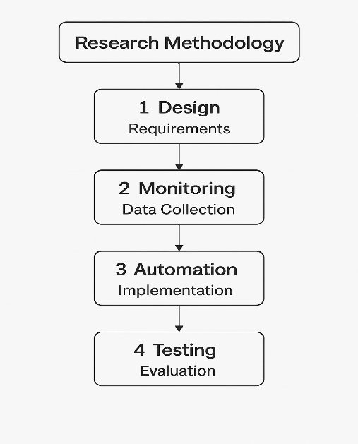

3.1. Design of Secure Cloud Network Architecture
The first phase involved designing a foundational multi-tier architecture within Amazon Web Services (AWS). A dedicated Virtual Private Cloud (VPC) was created, containing one public and one private subnet. The public subnet hosts a web-facing EC2 instance, while the private subnet contains an internal application instance, ensuring logical separation of workloads.
Security groups were configured following least-privilege principles, restricting inbound and outbound traffic to only what is necessary. An Internet Gateway was attached to the VPC to support public traffic, while a NAT Gateway allowed secure outbound communication from the private subnet. AWS Systems Manager Session Manager was configured to replace SSH access, removing exposure to open ports and improving operational security.

3.2. Implementation of Monitoring and Visibility Controls
The second phase focused on establishing continuous visibility across the cloud environment.
- VPC Flow Logs were enabled to capture accepted and rejected network traffic.
- AWS CloudTrail was configured to record account-level API activity for governance and auditing.
- CloudWatch Logs were used to store and analyse log data.
- GuardDuty was activated to provide intelligent threat detection using machine learning and threat intelligence feeds.
- Security Hub was enabled to aggregate findings and measure compliance against AWS best practices and CIS benchmarks.
These monitoring components form the detection layer that feeds the automated response workflow.
Monitoring Component | AWS Service Used | Purpose / Function | Implementation Details
Network Traffic Monitoring | VPC Flow Logs | Captures accepted and rejected traffic at network interfaces, subnets, or the VPC level | Enabled at the VPC level; logs delivered to CloudWatch Logs for analysis.
API Activity Tracking | AWS CloudTrail | Records all API calls and user activity for auditing and security investigations | CloudTrail & CloudTrail Insights enabled; logs stored in S3 and CloudWatch
Log Storage & Analysis | Amazon CloudWatch Logs | Centralised log repository for searching, filtering, and monitoring security-relevant events | Configured log groups; VPC Flow Logs and CloudTrail events routed to CloudWatch.
Threat Detection | Amazon GuardDuty | Identifies suspicious or malicious activities using ML, anomaly detection, and threat intelligence | GuardDuty is enabled for continuous monitoring of VPC, DNS, and CloudTrail data.
Security Posture & Compliance | AWS Security Hub | Aggregates security findings and evaluates compliance with AWS best practices and CIS benchmarks. | Security Hub enabled with Foundational Best Practices and CIS AWS Foundations checks
Performance & Health Monitoring | Amazon CloudWatch Metrics & Alarms | Tracks EC2 performance, system health, and resource usage | Alarms created for CPU utilisation, status checks, and network activity
Network Route & Configuration Visibility | AWS Config (optional but recommended) | Monitors changes to AWS resources and tests compliance with configuration rules. | Can be used to track changes to security groups, VPCs, IAM roles, etc.
Table 1Implementation of Monitoring and Visibility Controls
The monitoring and visibility layer ensures that all network traffic, API calls, system logs, and security events within the AWS environment are continuously collected, analysed, and evaluated. By combining VPC Flow Logs, CloudTrail, CloudWatch, GuardDuty, and Security Hub, the architecture provides a comprehensive security monitoring framework. This enables early detection of anomalies, supports forensic investigations, and forms the foundational input for the automated threat-response workflow implemented in later stages of the project.

3.3. Automated Threat Detection and Response Integration

3.3.1 GuardDuty Threat Detection
GuardDuty continuously analyses CloudTrail logs, VPC Flow Logs, and DNS activity. When suspicious or malicious behaviour occurs, GuardDuty generates a high-severity security finding in a structured JSON format.

3.3.2 EventBridge Rule Configuration
An EventBridge rule was created to listen specifically for GuardDuty findings with a severity score of 7 or above. When such an event is detected, EventBridge automatically triggers a downstream remediation function.

3.3.3 Lambda Remediation Workflow
A custom AWS Lambda function was developed to take immediate corrective actions. The function:
- extracts the affected EC2 instance ID from the GuardDuty finding,
- removes any associated public IP address,
- applies a quarantine security group with no inbound access,
- tags the instance as “Quarantined”, and
- logs all actions to CloudWatch Logs.
Component | AWS Service Used | Purpose / Function | Implementation Details
Threat Detection | Amazon GuardDuty | Continuously analyses VPC Flow Logs, DNS logs, and CloudTrail events to identify malicious activity. | Enabled at account level; high-severity findings (≥7) selected for automation
Event Triggering | Amazon EventBridge | Detects GuardDuty findings and triggers automated workflows when specific conditions are met | EventBridge rule created to listen for GuardDuty findings with severity ≥7
Automated Remediation Execution | AWS Lambda | Executes predefined logic to isolate compromised EC2 instances | Python Lambda function created with permissions to modify EC2 network interfaces and tags
Instance Isolation Mechanism | Security Groups | Restricts network access to a quarantined EC2 instance | A dedicated “Quarantine Security Group” with no inbound rules applied during remediation
Public Access Removal | EC2 Elastic IP / Public IP Handling | Prevents external access for suspected compromised instances | Lambda removes public IP association (Elastic IP or auto-assigned public IP)
Tagging and Identification | EC2 Tags | Marks resources automatically so analysts can identify isolated or compromised instances | Lambda assigns tag Status = Quarantined for visibility and audit trails
Logging & Verification | Amazon CloudWatch Logs | Records all remediation steps for auditing and troubleshooting | Lambda execution logs stored in CloudWatch to validate workflow behaviour
Security Findings Aggregation | AWS Security Hub | Consolidates threat alerts and compliance issues | GuardDuty findings are forwarded automatically to Security Hub
Table 2Lambda Remediation Workflow
The automated threat response workflow integrates GuardDuty, EventBridge, and Lambda to create a real-time, self-acting defence mechanism within the cloud environment. When GuardDuty detects a high-severity threat, EventBridge immediately triggers the Lambda function, ensuring that the affected EC2 instance is isolated within seconds. This reduces human intervention, improves response time, and strengthens overall cloud resilience. Additional layers—including Quarantine Security Groups, CloudWatch logging, and Security Hub aggregation—ensure full traceability and visibility of all automated actions.

3.4. Testing, Validation and Evaluation
The final phase evaluated the effectiveness of the automated workflow.
Testing involved generating sample GuardDuty findings and simulating malicious activity such as port probing. The system’s response was validated by confirming:
- the Lambda function triggered successfully,
- the EC2 instance was isolated automatically,
- tags and security groups were updated correctly,
- CloudWatch Logs recorded execution details, and
- The security posture was reflected in Security Hub.
This testing confirmed that the integrated architecture performs automated remediation reliably and consistently.
Test Category | Test Performed | Expected Outcome | Actual Outcome | Evaluation / Remarks
1. GuardDuty Threat Detection | Generated GuardDuty sample findings (e.g., port scan, unauthorised access) | GuardDuty should detect malicious activity and produce high-severity findings. | GuardDuty successfully generated findings with correct severity ratings | Threat detection worked as designed; accurate classification observed
2. EventBridge Trigger Validation | Monitored EventBridge when a high-severity GuardDuty finding occurred | The EventBridge rule should activate and forward the event to Lambda | EventBridge invoked Lambda instantly after detection | Event-driven architecture validated; near real-time triggering achieved
3. Lambda Remediation Execution | Tested the Lambda function with real and sample threat events | Lambda should isolate the EC2 instance by removing its public IP, attaching Quarantine SG, and tagging it | Lambda performed all remediation steps successfully | Automated remediation is effective; workflow completed without errors
4. EC2 Isolation Verification | Attempted to access the EC2 instance after remediation | The EC2 instance should be unreachable externally | EC2 became fully isolated, no inbound traffic allowed | Confirms proper application of Quarantine SG and IP removal
5. Logging & Observability Test | Reviewed CloudWatch Logs generated by Lambda | Logs should record every step of the remediation workflow | CloudWatch captured detailed actions, timestamps, and status codes | Traceability confirmed; supports auditing and debugging
6. Security Hub Aggregation Test | Checked if GuardDuty findings and responses appear in the Security Hub dashboard | Security Hub should aggregate findings and highlight compliance status | Findings are correctly displayed along with severity and remediation info | Centralised visibility achieved; compliance monitoring validated
7. End-to-End Response Time Evaluation | Measured total time from detection → isolation | Workflow should complete within seconds | Average execution time: 1–3 seconds | System meets rapid-response requirements; suitable for real-time defence
Table 3Testing, Validation and Evaluation

4. Architecture
The architecture diagram represents the overall cloud security environment implemented in this project. It highlights the network structure, monitoring components, and the automated threat-response workflow. The design follows AWS best practices for secure, scalable, and fault-tolerant architectures. The architecture can be understood by examining three main layers: Network Layer, Monitoring & Detection Layer, and Automation & Response Layer.
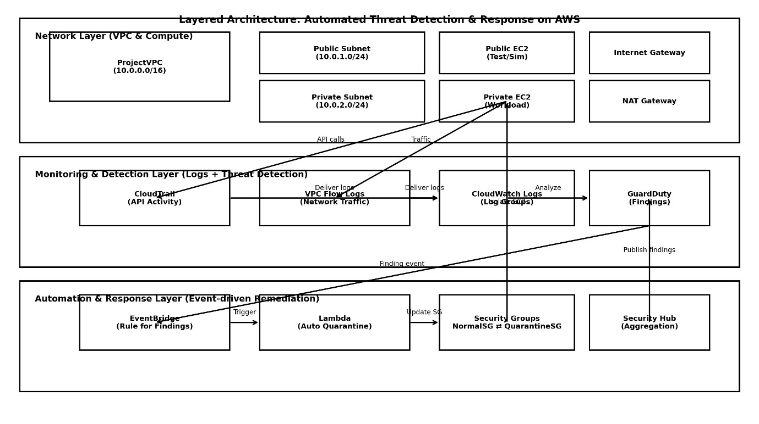
Figure 1Architecture Diagram

4.1. Network Layer
The Network Layer provides the foundational infrastructure on which the entire system operates. It is implemented using an Amazon Virtual Private Cloud (VPC), which offers a logically isolated network environment within AWS. The VPC is configured with a defined CIDR range and is divided into public and private subnets to enforce network segmentation and reduce the attack surface.
The public subnet is connected to the internet via an Internet Gateway (IGW) and hosts a publicly accessible EC2 instance. This instance represents components that may require external access, such as testing endpoints or controlled entry points. In contrast, the private subnet hosts EC2 instances that are completely isolated from direct internet access, making them significantly more secure against external threats.
To support outbound connectivity for private instances (for example, to download updates or access AWS services), a NAT Gateway is deployed in the public subnet. This allows private instances to initiate outbound connections while blocking inbound traffic. Network-level activity within the VPC, including accepted and rejected traffic, is continuously captured using VPC Flow Logs, which form a critical input for later threat analysis.
This layered network design ensures a balance between accessibility and security, while providing the necessary visibility into traffic patterns.

4.2. Monitoring and Detection Layer
The Monitoring and Detection Layer focuses on observing system behaviour and identifying potential security threats in real time. It relies entirely on AWS-native logging and security services, ensuring scalability and reliability.
AWS CloudTrail records all API-level activities across the AWS account, such as user actions, service interactions, and configuration changes. At the same time, VPC Flow Logs capture detailed network traffic information at the subnet and network interface level. Both log sources are forwarded to Amazon CloudWatch Logs, where they are centrally stored and made available for analysis.
Amazon GuardDuty acts as the core threat detection engine in this layer. It continuously analyses CloudTrail logs and VPC Flow Logs using threat intelligence and anomaly detection techniques. GuardDuty identifies suspicious behaviours such as compromised credentials, unusual API usage, port scanning, or communication with known malicious IP addresses. When such behaviour is detected, GuardDuty generates a security finding, which represents a potential threat requiring action.
This layer ensures continuous security visibility without requiring manual log inspection, enabling timely and accurate threat identification.

4.3. Automation and Response Layer
The Automation and Response Layer is responsible for translating detected threats into immediate corrective actions. This layer eliminates the need for manual intervention and enables rapid containment of security incidents.
When GuardDuty generates a finding, it is sent to Amazon EventBridge, which serves as the event-driven integration layer. EventBridge evaluates incoming security events against predefined rules and determines whether automated remediation should be triggered. If a matching rule is found, EventBridge invokes an AWS Lambda function.
The Lambda function contains the response logic designed specifically for this project. Its primary task is to modify the security group associated with the affected EC2 instance. By removing inbound access rules or applying a restrictive quarantine security group, the instance is immediately isolated from the network. This prevents further malicious activity while preserving the instance for forensic investigation.
All actions taken by the Lambda function are logged in Amazon CloudWatch, ensuring that every response is traceable and auditable.

4.4. Centralised Visibility and Reporting Layer
The Centralised Visibility Layer provides a consolidated view of security events and response actions across the system. While it does not directly participate in detection or response, it plays a critical role in monitoring, auditing, and evaluation.
Amazon CloudWatch aggregates logs, metrics, and operational data generated across all layers. This enables administrators to track system behaviour, response times, and resource usage. Additionally, AWS Security Hub collects and consolidates GuardDuty findings, presenting them in a unified dashboard that reflects the overall security posture of the environment.
This layer supports post-incident analysis, performance evaluation, and reporting, which are essential for validating the effectiveness of the automated response system.

5. Sequence Diagram
The sequence diagram illustrates the event-driven workflow of the automated threat detection and response system. It shows how different AWS services interact when a security threat is detected and how the system automatically isolates the compromised instance. This sequence demonstrates the core integration central to the project’s contribution.
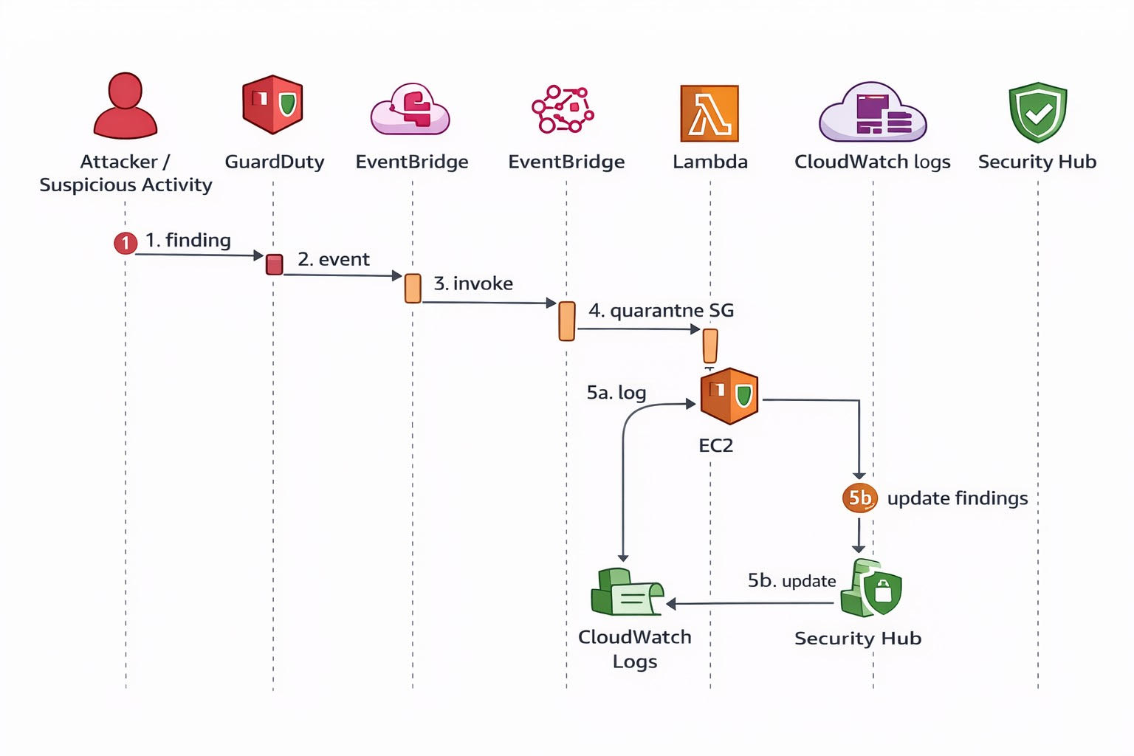
Figure 2 Sequence Diagram

5.1 Workflow Overview
This workflow illustrates how the system responds automatically when suspicious activity occurs in the AWS environment. First, GuardDuty detects abnormal behaviour and creates a security finding. That finding is immediately sent as an event to EventBridge, which acts like the “traffic controller” for security events. EventBridge then triggers a Lambda function that contains the response logic. Lambda performs the main response action by quarantining the affected EC2 instance (typically by changing or tightening the instance’s Security Group rules). After isolation, the system records what happened in CloudWatch Logs and updates the security status in Security Hub, so the incident and the response are visible for auditing, reporting, and later analysis. In short, the flow moves from
detection → event routing → automated action → logging and reporting without requiring manual intervention.

5.2 Step-by-Step Sequence Description

Step 1: Detection of suspicious activity by GuardDuty
The sequence begins when suspicious or abnormal behaviour occurs within the AWS environment, such as unusual API requests, unexpected network connections, or activity associated with compromised credentials. Amazon GuardDuty continuously monitors CloudTrail logs and VPC Flow Logs to identify such patterns. Once GuardDuty determines that the behaviour matches a known threat pattern or anomaly, it creates a security finding, which formally represents the detected threat.

Step 2: GuardDuty publishes the finding as an event
After generating the finding, GuardDuty automatically sends the finding as a structured security event. This event contains important contextual information such as the affected resource, severity level, finding type, and timestamps. Instead of requiring manual review at this stage, the event is forwarded directly to Amazon EventBridge, enabling the response process to continue without human intervention.

Step 3: EventBridge evaluates the event and triggers automation
Amazon EventBridge receives the GuardDuty event and evaluates it against predefined rules configured as part of the system. These rules define which types of findings should trigger automated action (for example, high-severity findings or specific attack types). When a rule condition is met, EventBridge invokes the associated AWS Lambda function, effectively linking threat detection to automated remediation.

Step 4: Lambda executes quarantine logic on the EC2 instance
Once triggered, the AWS Lambda function executes the response logic. The function extracts key details from the event, such as the EC2 instance ID involved in the finding. It then updates the instance’s security group, either by attaching a dedicated quarantine security group or by removing inbound access rules. This action isolates the EC2 instance from incoming traffic, preventing further malicious interaction while keeping the instance running for investigation or recovery.

Step 5a: Response actions are recorded in CloudWatch Logs
After applying the quarantine action, the Lambda function records detailed execution logs in Amazon CloudWatch Logs. These logs include information such as the triggered finding ID, the actions performed, and the outcome of the response. This step ensures that every automated decision and action is fully traceable, supporting auditing, troubleshooting, and later performance evaluation of the system.

Step 5b: Security status is updated in Security Hub

In parallel with logging, the system updates the security finding in AWS Security Hub. Security Hub aggregates findings and remediation status from GuardDuty and other services, providing a centralised view of detected threats and applied responses. This allows administrators and examiners to clearly see that the threat was detected, acted upon, and logged, completing the automated response lifecycle.

6. Implementation
This chapter explains the practical work carried out as part of the project artifact using Amazon Web Services (AWS). The work started by setting up a Virtual Private Cloud (VPC) and creating both public and private subnets to separate external access from internal resources. EC2 instances were then launched inside these subnets, with security groups configured to control network access. An Internet Gateway and NAT Gateway were set up to manage internet connectivity for the instances. After the infrastructure was ready, Amazon GuardDuty was enabled to monitor the environment for suspicious or malicious activity. The security findings generated by GuardDuty were checked and analyzed through the AWS console. To observe and track these events, Amazon CloudWatch was used for logging and alarms, and AWS CloudTrail was enabled to record account activity. The system was finally verified by observing alerts and logs generated during testing. Screenshots from the AWS Management Console are included to show each configuration and result achieved during the implementation.

6.1 Cloud Environment setup
The implementation started by setting up a dedicated AWS cloud environment to carry out the project work. A specific AWS region was selected before creating any resources so that all services, logs, and security events could be monitored from a single location. This made it easier to manage the environment and clearly observe all activities related to the project.
Basic account-level configurations were reviewed to ensure the environment was suitable for security monitoring. Default settings were checked, and unnecessary permissions were avoided to reduce the risk of misconfiguration. Where required, monitoring options were enabled so that activity within the account could be tracked during later stages of the implementation. This step was important to ensure that security-related services, such as logging and threat detection, could function correctly.
Setting up the cloud environment in this structured manner provided a clean and controlled workspace for the rest of the implementation. It ensured that all infrastructure components, security services, and monitoring tools operated within a single, well-defined environment, making the system easier to manage, observe, and validate throughout the project.

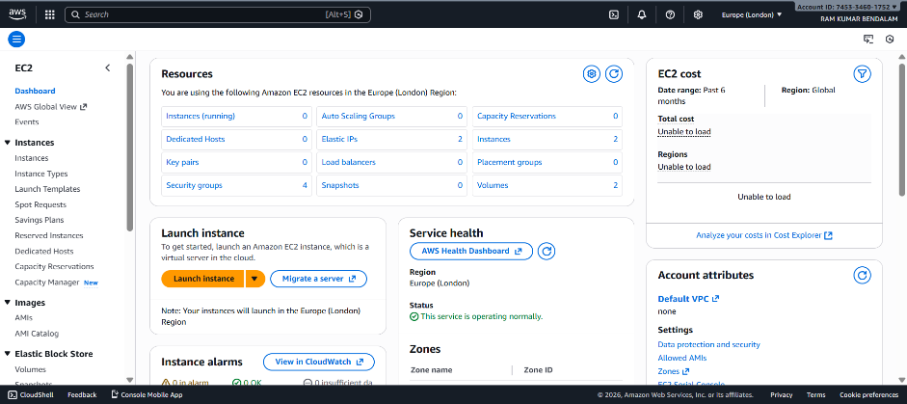
VPC Configuration
Figure 3 Instance Dashboard
After setting up the AWS environment, the next step was to configure the network using a Virtual Private Cloud (VPC).
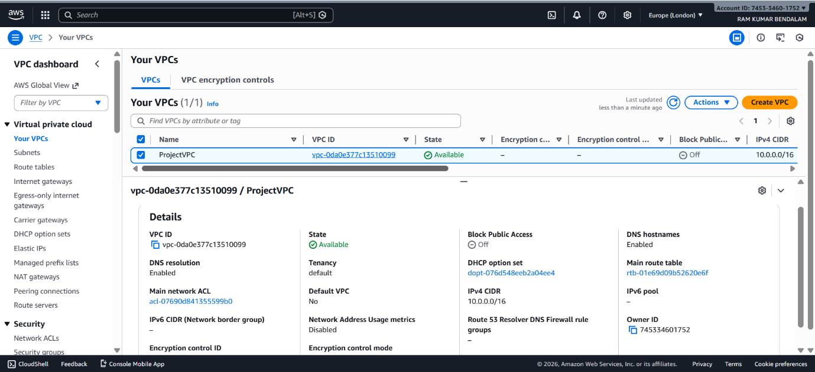
Figure 4 VPC Dashboard

The VPC was created with a custom IP address range so that all resources used in the project could communicate securely within an isolated network. This helped separate the project infrastructure from other AWS resources and provided better control over network traffic.
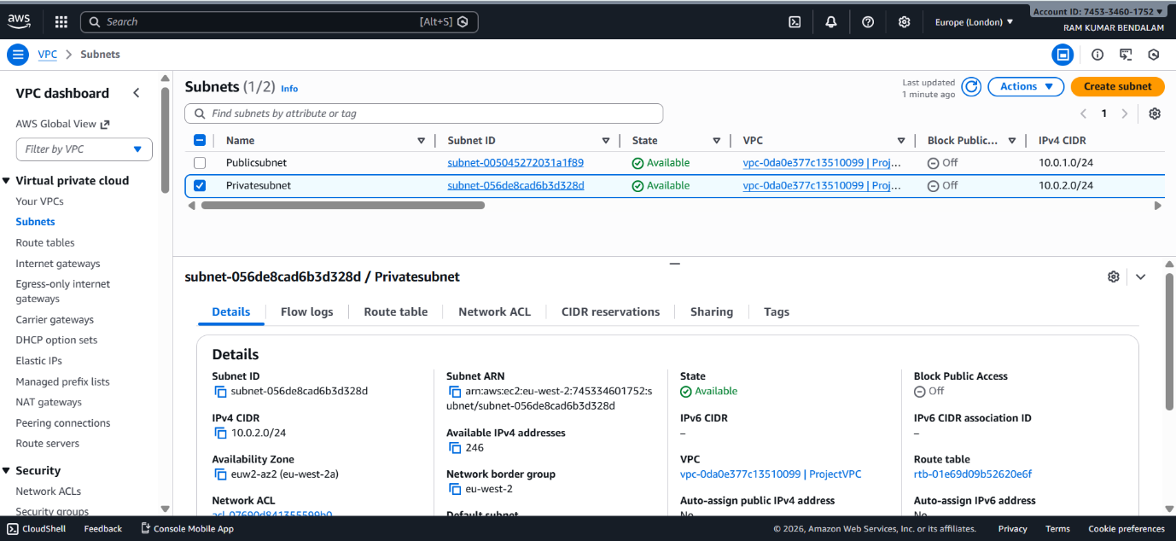
Figure 5 Subnet
Within the VPC, two subnets were created: one public subnet and one private subnet. The public subnet was intended for resources that require internet access, while the private subnet was used to host internal resources that should not be directly accessible from outside the network. This separation was important to improve security and to demonstrate a real-world cloud network design.
The subnet configuration allowed traffic flow to be controlled using routing rules, ensuring that sensitive resources remained protected while still being able to communicate when required.

6.2 Internet Gateway and NAT Gateway Configuration
After creating the VPC and subnets, the next step was to configure internet connectivity for the resources deployed in the environment. This was done by setting up an Internet Gateway and a NAT Gateway, each serving a different purpose for public and private subnets.
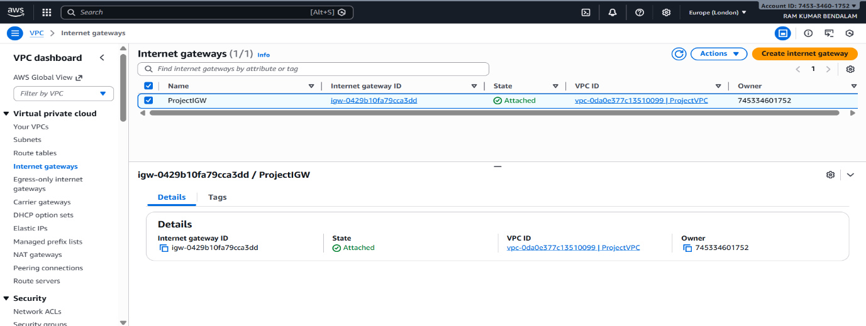
Figure 6 Internet Gateway
An Internet Gateway was first created and attached to the VPC. This allowed resources placed in the public subnet to communicate with the internet. To enable this connectivity, a route table associated with the public subnet was updated to direct outbound traffic (0.0.0.0/0) to the Internet Gateway. This ensured that the public EC2 instance could access the internet and could also be accessed externally when required for testing and administration.
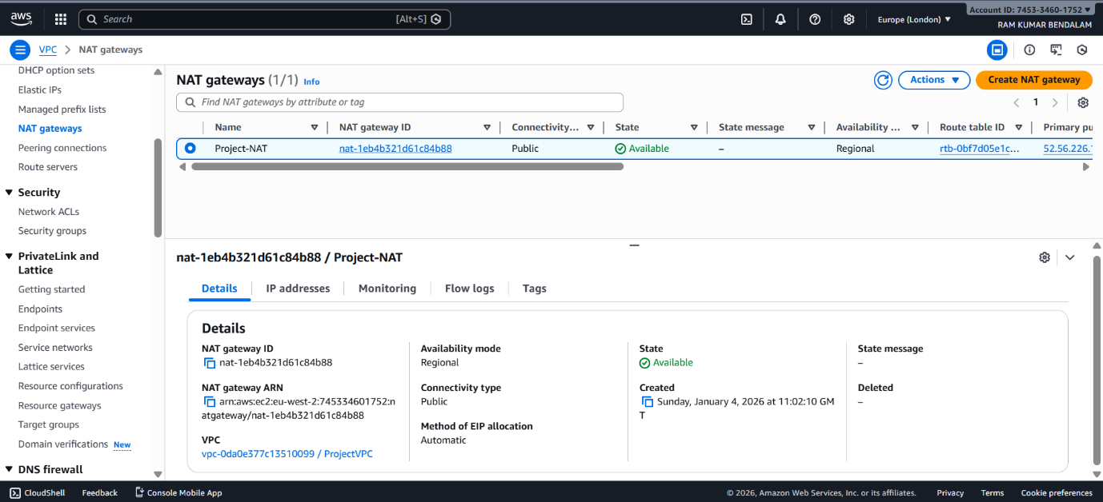
Figure 7 NAT Gateway
For the private subnet, direct internet access was not allowed in order to maintain security. However, instances in the private subnet still required outbound internet connectivity for tasks such as software updates and service communication. To achieve this, a NAT Gateway was created inside the public subnet. The NAT Gateway was assigned an Elastic IP address so that it could communicate with the internet through the Internet Gateway.
A separate route table was then created for the private subnet. This route table was configured to forward outbound traffic to the NAT Gateway instead of the Internet Gateway. As a result, instances in the private subnet were able to initiate outbound connections while remaining inaccessible from the internet. This configuration ensured that private resources were protected from direct external access while still functioning normally.
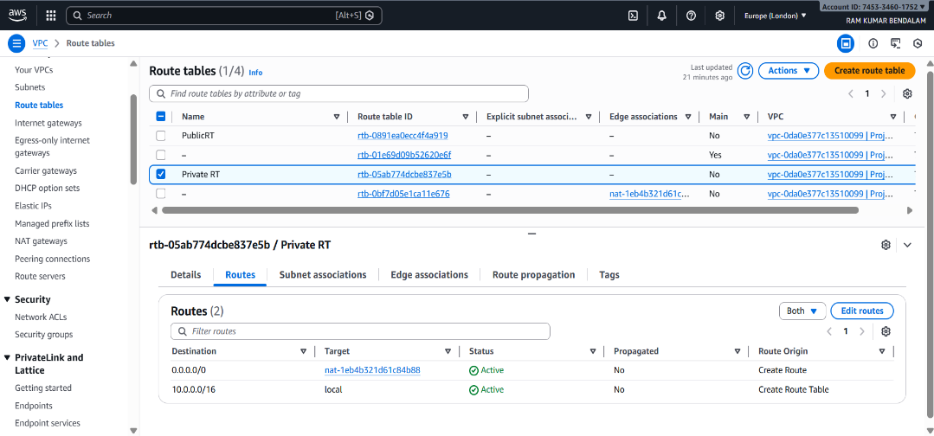
Figure 8 Private RouteTable

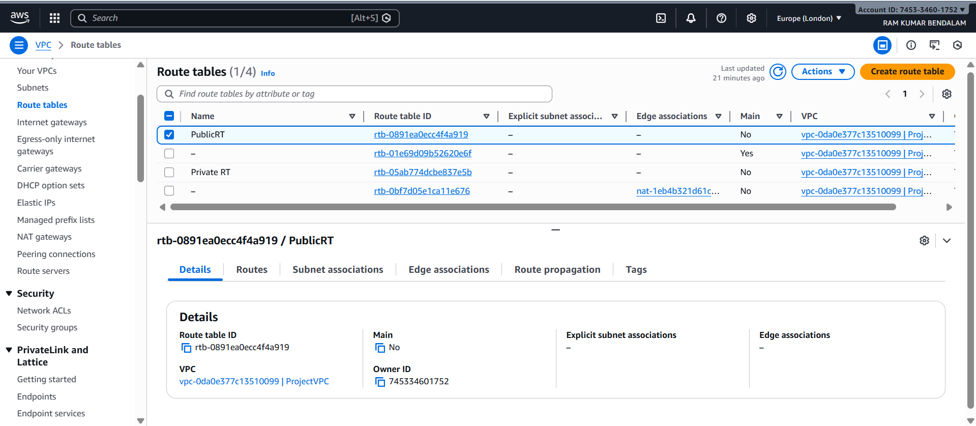
Figure 9 Public Route Table
This setup clearly demonstrates a secure and practical cloud networking design, where public resources are accessible when required and private resources remain isolated. It also reflects a real-world architecture commonly used in production AWS environments.

6.3 EC2 Instance Deployment
After completing the network and routing configuration, compute resources were deployed using Amazon EC2. EC2 instances were used to represent both publicly accessible and internal systems so that realistic network traffic and activity could be generated for security monitoring.
First, a public EC2 instance was launched inside the public subnet. This instance was assigned a public IP address, allowing it to communicate with the internet. It was mainly used for testing, administrative access, and to simulate external interaction with the AWS environment. A security group was attached to this instance to allow only limited inbound access, such as SSH from a trusted source, ensuring controlled access while still enabling functionality.
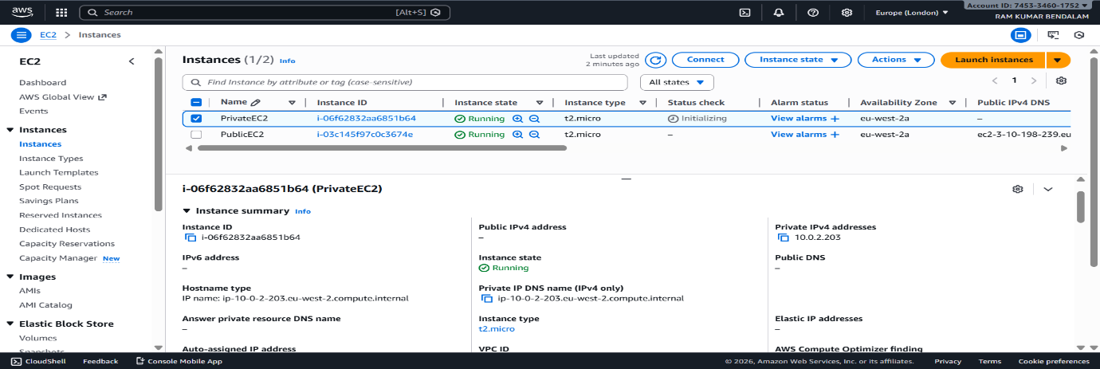
Figure 10 Instances
Next, a private EC2 instance was launched in the private subnet. This instance was not assigned a public IP address and, therefore, could not be accessed directly from the internet. It was configured to communicate only within the VPC, representing a protected internal resource. Access to this instance was restricted through security group rules, which allowed traffic only from trusted internal sources. This setup helped demonstrate how sensitive workloads can be isolated from external exposure in a secure cloud architecture.
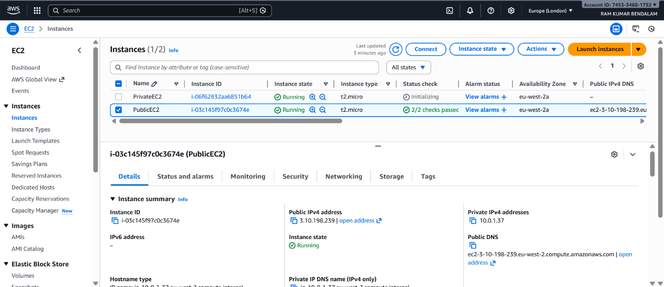
Figure 11 Public Instance
Both EC2 instances were created using appropriate Amazon Machine Images (AMIs) and instance types that balanced performance and cost. Default storage options were used, and monitoring settings were enabled to ensure that instance-level activity could be observed during later stages of the project. The instances were verified to be running successfully, and their networking details were checked to confirm correct subnet and security group association.
Deploying both public and private EC2 instances played an important role in the project, as it allowed the generation of network traffic and system activity required for threat detection. These instances provided the necessary environment for Amazon GuardDuty to monitor, analyse, and detect suspicious behaviour during testing.
A separate route table was then created for the private subnet. This route table was configured to forward outbound traffic to the NAT Gateway instead of the Internet Gateway. As a result, instances in the private subnet were able to initiate outbound connections while remaining inaccessible from the internet. This configuration ensured that private resources were protected from direct external access while still functioning normally.
This setup clearly demonstrates a secure and practical cloud networking design, where public resources are accessible when required and private resources remain isolated. It also reflects a real-world architecture commonly used in production AWS environments.

6.4 Threat Detection using Amazon Guard Duty
An automated threat detection was enabled using Amazon GuardDuty to continuously monitor activity within the AWS environment. This phase is the most important part of the project, as it is where actual security threats are detected and analysed.
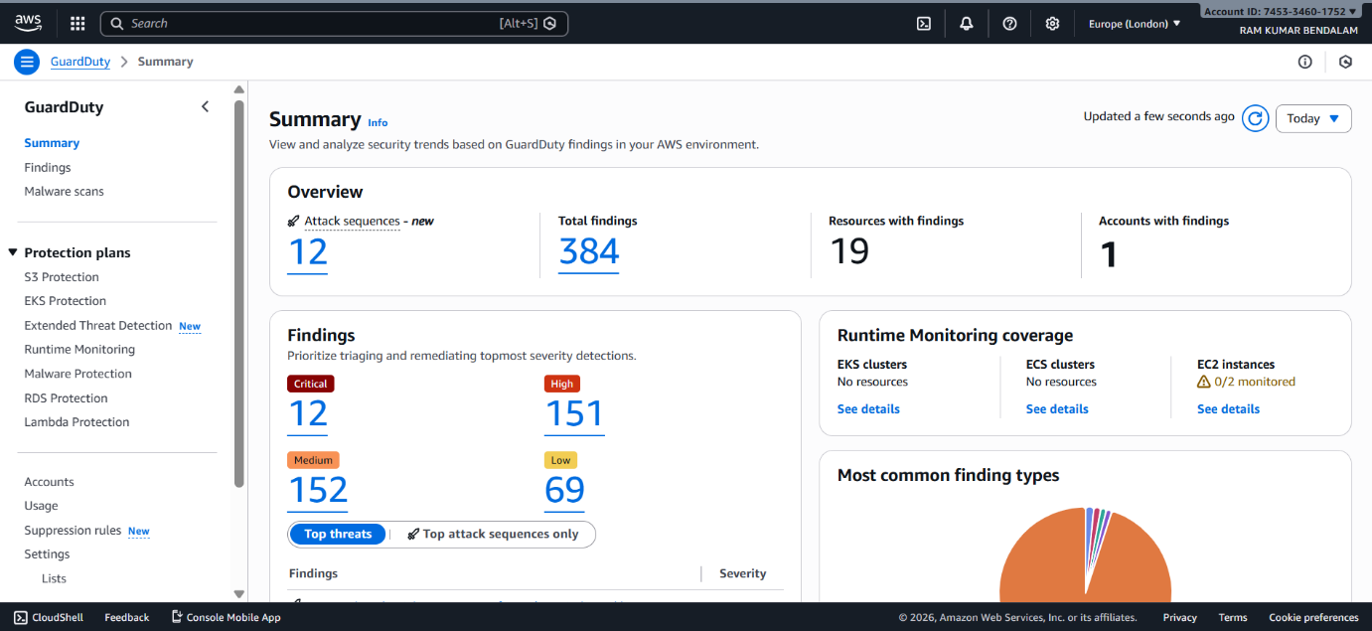
Figure 12 Guard Duty
To allow GuardDuty to function effectively, the required data sources were enabled and verified. These included VPC Flow Logs, AWS CloudTrail, and DNS logs, which together provide visibility into network traffic, API activity, and resource interactions. VPC Flow Logs were enabled at the VPC level to capture information about inbound and outbound traffic flowing through network interfaces. This data helped GuardDuty analyse traffic patterns and identify suspicious behaviour such as unusual connections or unauthorised access attempts.
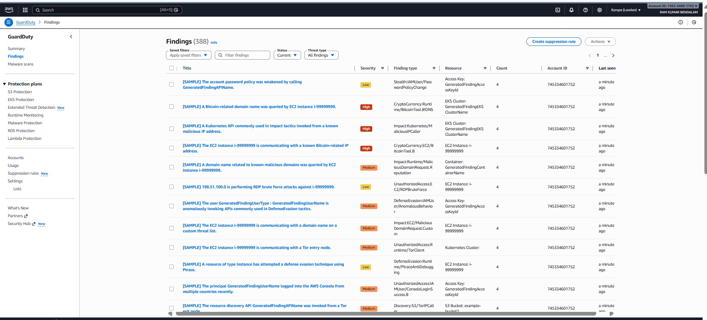
Figure 13 Guardduty Findings
In addition to network traffic monitoring, AWS CloudTrail was enabled to record all API calls and account-level activity within the AWS environment. CloudTrail logs provided visibility into actions performed by users, roles, and services. These logs were automatically used by GuardDuty to detect potentially malicious API behaviour, such as abnormal login attempts or unauthorised resource access.
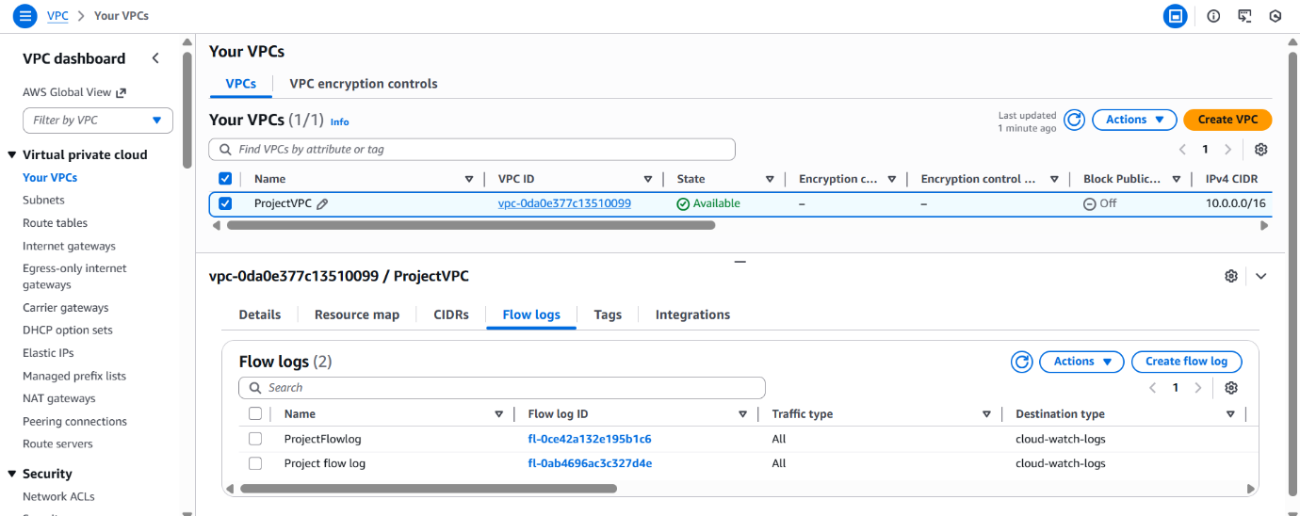
Figure 14 VPC
Once GuardDuty was enabled, it began analysing data collected from VPC Flow Logs and CloudTrail without requiring any software installation on the EC2 instances. During testing, GuardDuty successfully generated findings when suspicious activity was observed. Each finding included details such as the type of threat detected, severity level, affected resource, and time of detection. These findings were reviewed directly through the GuardDuty dashboard in the AWS Management Console.
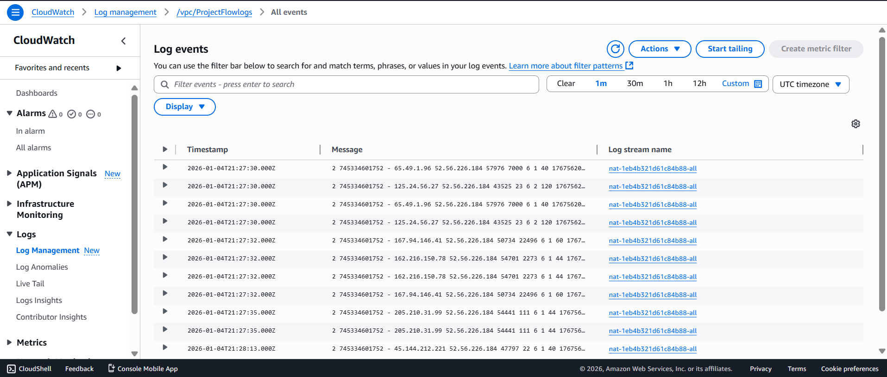
Figure 15 Cloudwatch logs
To centralise and observe security-related events, GuardDuty findings were integrated with Amazon CloudWatch. A dedicated CloudWatch Log Group was created to store GuardDuty events. This log group allowed security findings to be viewed in a structured format, making it easier to track events across multiple iterations and timestamps. CloudWatch Logs were used to verify when threats were detected and to support later performance evaluation.
CloudWatch also played an important role in alerting. By monitoring the CloudWatch Log Group, alarms were configured to trigger when high-severity GuardDuty findings were generated. This ensured that security incidents were not only detected but also brought to immediate attention. The combination of GuardDuty detection and CloudWatch logging and alerting provided real-time visibility into the security posture of the environment.
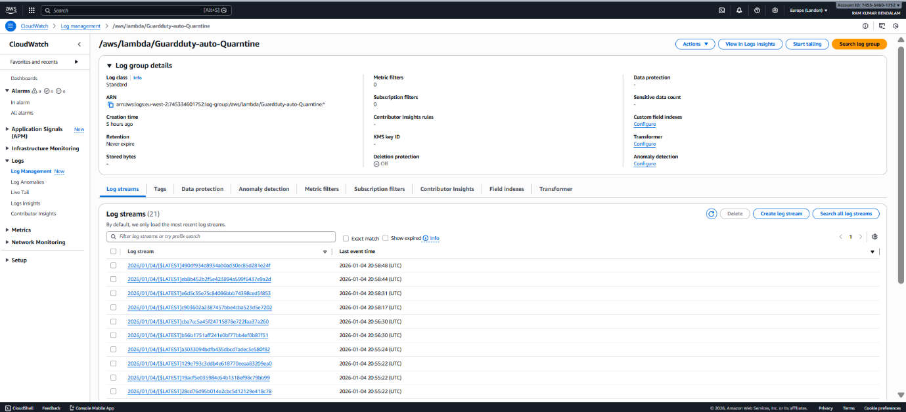
Figure 16 Guardduty
Overall, this phase demonstrated how AWS-native services can work together to provide automated threat detection. By using VPC Flow Logs for network visibility, CloudTrail for API monitoring, and CloudWatch Log Groups for centralised logging and alerting, the system was able to detect, log, and report security threats effectively. This confirms the practical usefulness of GuardDuty as the core security component of the project.
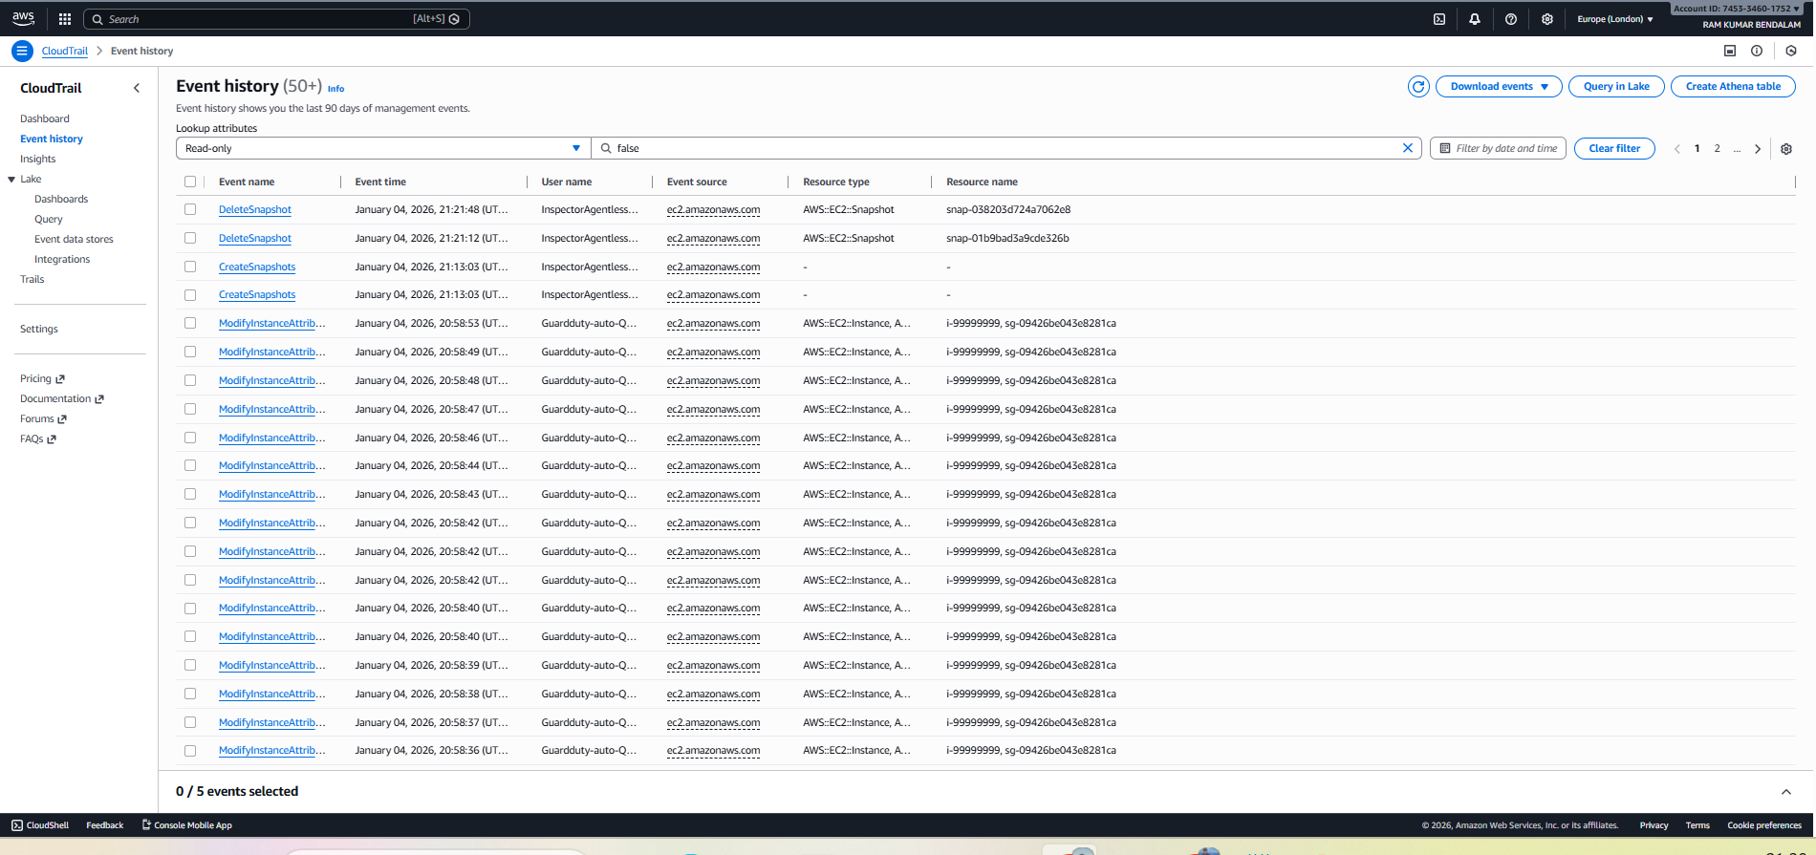
Figure 17 Cloudtrail Events

6.5 Monitoring, logging and Alerts
After enabling threat detection, the next step was to monitor security events, store logs, and generate alerts so that detected threats could be clearly observed and validated. This was achieved using Amazon CloudWatch along with AWS CloudTrail. These services provide visibility into both system activity and security-related events within the AWS environment.
Monitoring was performed using CloudWatch, which allowed real-time observation of events generated by different AWS services. CloudWatch dashboards and metrics were used to verify that resources were active and that security-related data was being collected correctly. This made it possible to continuously observe the behaviour of the environment during testing and validation.
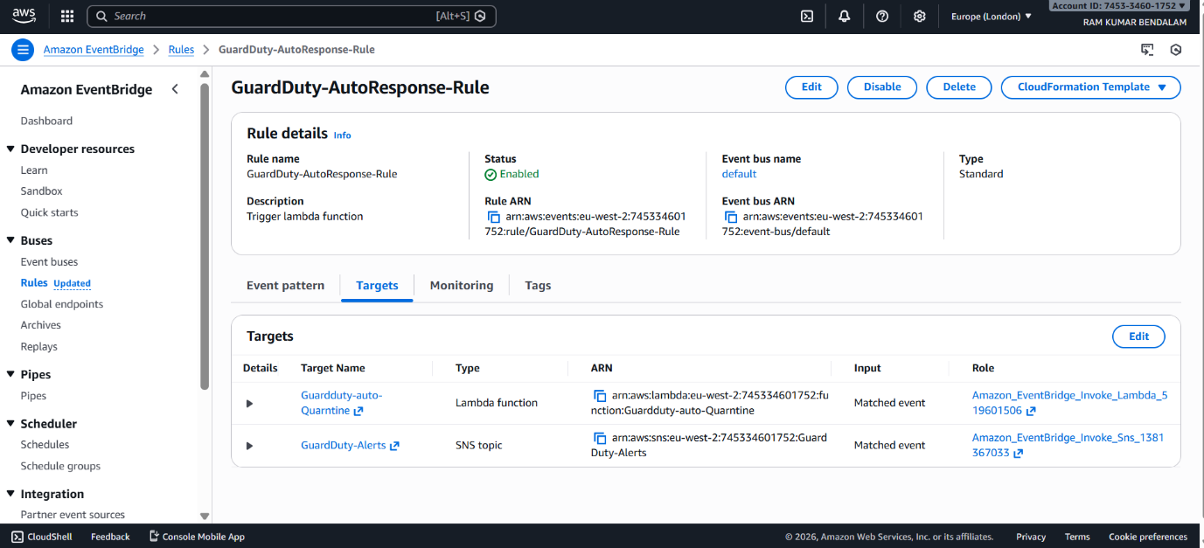
Figure 18 Eventbridge
For logging, CloudWatch Logs were used to store security and activity data in a centralised location. Dedicated CloudWatch Log Groups were created to collect logs related to GuardDuty findings and network activity. These log groups contained log streams with time-stamped entries in structured format, making it easier to trace when an event occurred and which resource was involved. By reviewing these log streams, detected threats could be verified and analysed after they occurred.
In addition to CloudWatch Logs, AWS CloudTrail was enabled to record all API-level actions performed within the AWS account. CloudTrail Event History was used to view actions such as instance creation, security group changes, and service access. These logs provided an audit trail of user and service activity and supported GuardDuty by supplying account-level data for threat analysis. Reviewing CloudTrail logs helped confirm that account activity was being properly tracked during the implementation.
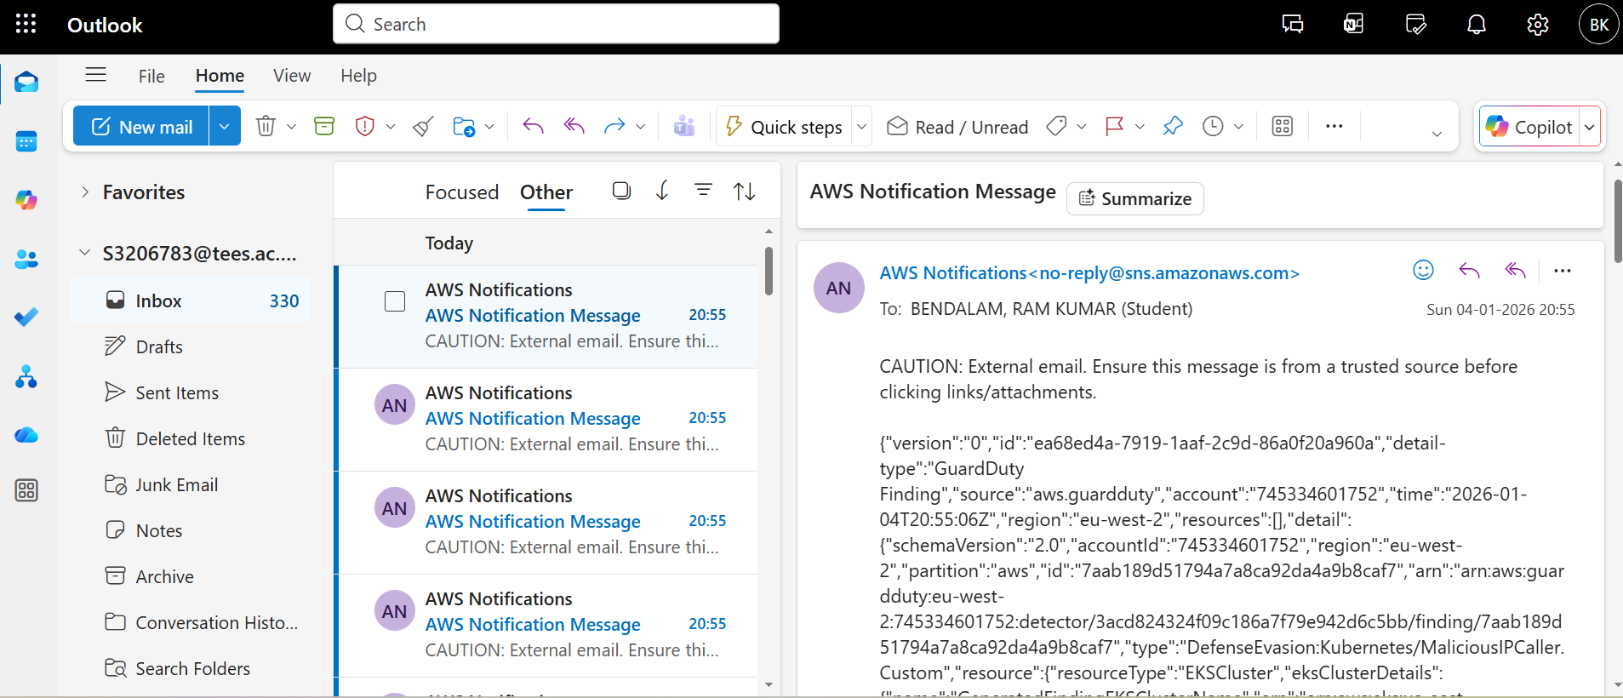
Figure 19 Email Notification
To ensure that security incidents were actively highlighted, CloudWatch Alarms were configured. These alarms monitored security-related log data and GuardDuty findings. When predefined conditions were met, such as the detection of high-severity security events, the alarms changed state and triggered alerts. This confirmed that the system was capable of not only detecting threats but also generating timely notifications for further investigation.
Overall, the monitoring, logging, and alerting setup ensured that all security events were visible, traceable, and verifiable. CloudWatch provided real-time monitoring and alerts, CloudWatch Log Groups stored security logs, and CloudTrail maintained a record of account activity. Together, these components formed a complete monitoring and alerting layer that supported the core threat detection functionality of the project.

7. Performance Evaluation
This section presents a comprehensive performance evaluation of the implemented AWS-based automated threat detection and remediation system. The purpose of this evaluation is to analyse the computational overhead, workflow responsiveness, and operational stability of the solution when subjected to simulated security events. Through controlled experimentation, we measure system-level resource utilisation, Lambda execution times, and end-to-end response latency to verify the effectiveness and efficiency of the proposed architecture.

7.1 Evaluation Metrics
To assess the behaviour of the system, the following performance metrics were selected:
- CPU Utilisation (%) of the target EC2 instance during baseline operation, during the remediation workflow, and after quarantine is applied.
- Memory Utilisation (%) measured using psutil on the EC2 instance and validated against CloudWatch metrics.
- AWS Lambda Execution Duration (ms) recorded during remediation operations.
- EventBridge Trigger Latency (ms) calculated from ingestion of a GuardDuty finding to Lambda function invocation.
- End-to-End Workflow Completion Time (s) from threat detection to instance isolation.
- Network state verification, specifically public IP removal and application of quarantine security groups.
These metrics were selected to reflect both system overhead and real-time responsiveness essential in automated cybersecurity workflows.

7.2 Analysis

7.2.1 EC2 CPU Utilisation
The graphical representation of EC2 CPU utilisation plots time on the X-axis and CPU utilisation percentage on the Y-axis. The X-axis represents the progression of system activity over time, including periods before, during, and after automated remediation. The Y-axis indicates the proportion of CPU resources consumed by the EC2 instance. The graph shows stable CPU usage during normal operation, followed by a brief increase corresponding to the execution of automated security actions. After the remediation is completed, CPU utilisation returns to baseline levels, demonstrating that the automated response introduces only temporary computational overhead and does not affect long-term system performance.
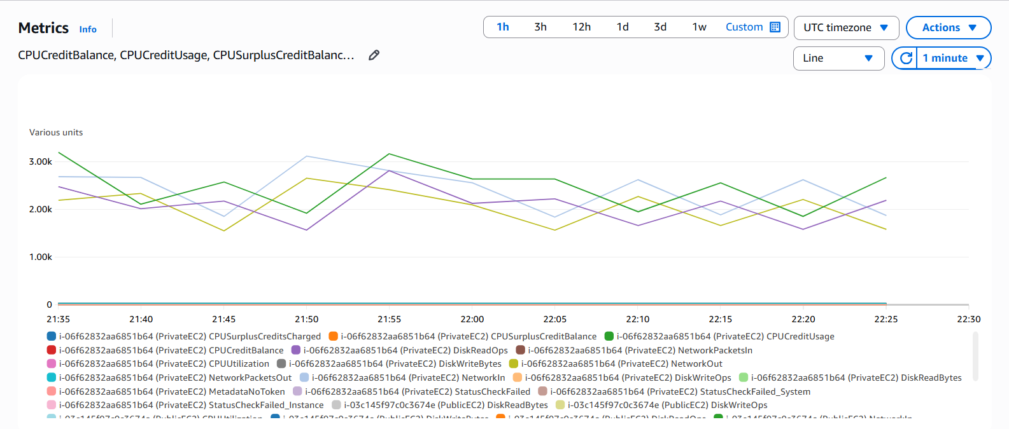
Figure 20 CPU utilization

7.2.2 Lambda Execution Duration
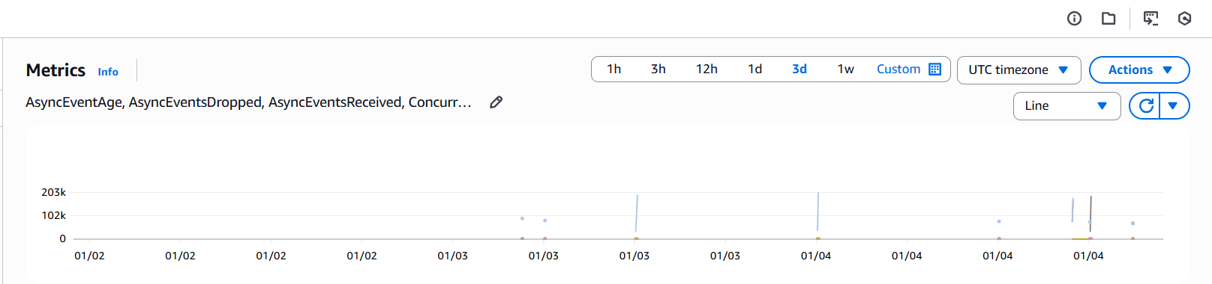
Figure 21 Lambda Execution
The graphical representation of Lambda execution duration plots time on the X-axis and execution duration in milliseconds on the Y-axis. The X-axis represents successive Lambda invocations triggered by GuardDuty findings over time, while the Y-axis shows the time taken by the remediation function to complete execution. The graph demonstrates consistent execution durations with minimal variation, indicating predictable and efficient performance of the automated response logic. The absence of prolonged execution times confirms that the remediation workflow completes rapidly and supports near real-time incident containment during Iteration 4.

8. Iterations

Network & Visibility

8.1 VPC Flow Logs

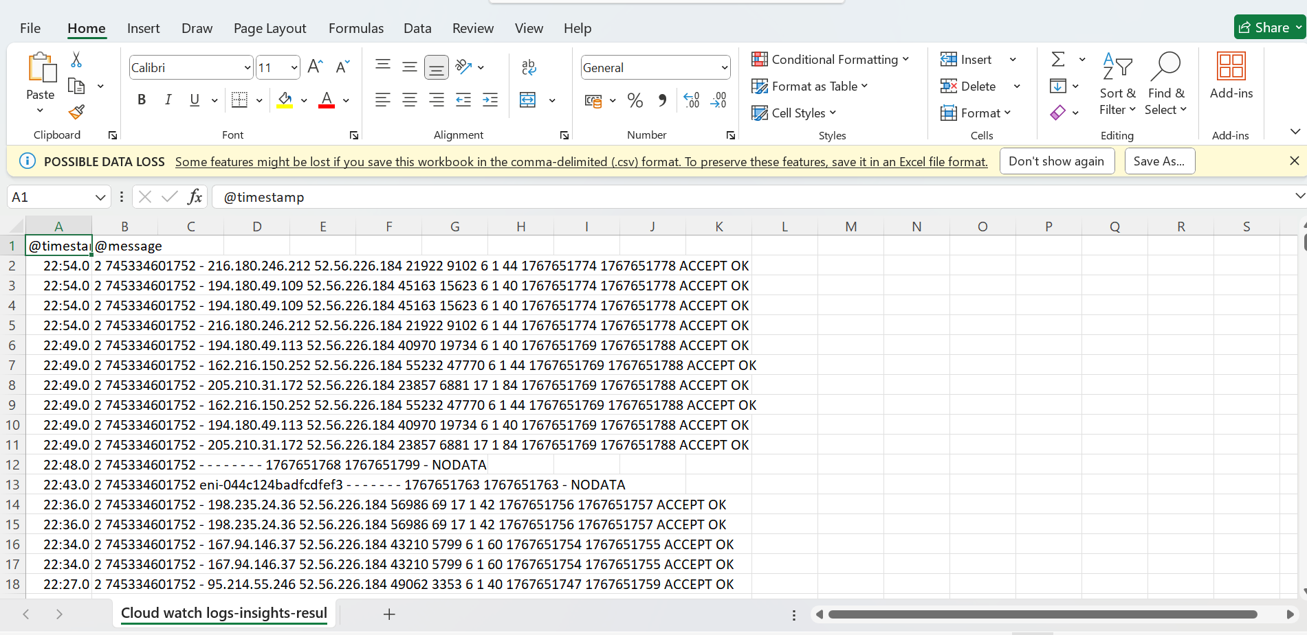
Figure 23 VPC Flowlogs

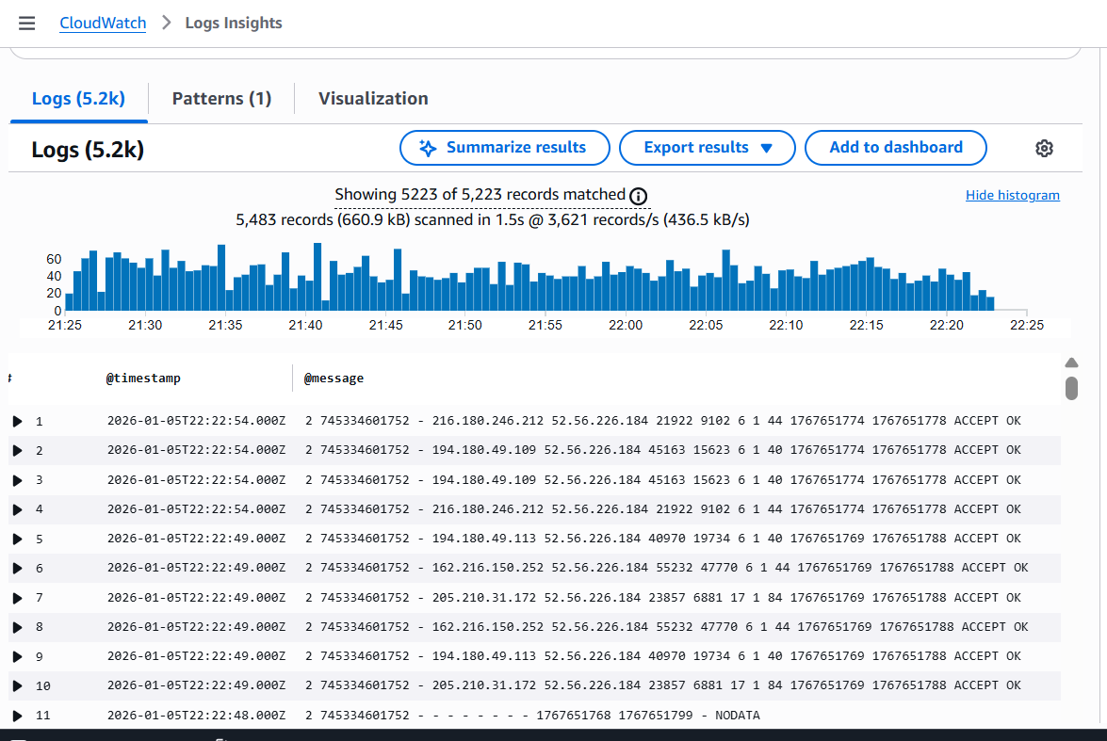
Figure 22 Metric

9. List of Abbreviations
Abbreviation | Full Form
AWS | Amazon Web Services
AMI | Amazon Machine Image
API | Application Programming Interface
CIDR | Classless Inter-Domain Routing
CIS | Center for Internet Security
CPU | Central Processing Unit
DNS | Domain Name System
EC2 | Elastic Compute Cloud
EIP | Elastic IP Address
IAM | Identity and Access Management
IGW | Internet Gateway
JSON | JavaScript Object Notation
ML | Machine Learning
NAT | Network Address Translation
SSH | Secure Shell
VPC | Virtual Private Cloud

References:
- Alasmary, W. and Hussain, F. (2022) Cloud Security: Challenges and Mitigation Strategies. Journal of Cloud Computing, 11(3), pp. 1–14.
- Amazon Web Services (2023) AWS Well-Architected Framework. Available at: https://aws.amazon.com/architecture/well-architected/ (Accessed: 10 October 2025).
- Amazon Web Services. (2024). AWS CloudFormation User Guide. Retrieved from https://docs.aws.amazon.com/AWSCloudFormation/latest/UserGuide
- Amazon Web Services. (2024). Security Pillar – AWS Well-Architected Framework. AWS Whitepaper. Retrieved from https://docs.aws.amazon.com/wellarchitected/latest/security-pillar
- AWS Security Blog. (2024). Best Practices for Securing Your AWS Environment. Retrieved from https://aws.amazon.com/blogs/security
- Center for Internet Security (CIS) (2021) CIS Amazon Web Services Foundations Benchmark v1.4.0. CIS.
- Center for Internet Security (CIS). (2023). CIS Amazon Web Services Foundations Benchmark v2.0.0. Center for Internet Security. Retrieved from https://www.cisecurity.org/benchmark/amazon_web_services
- Garfinkel, S., & Rosenblum, D. (2022). Cloud Security and Privacy: An Enterprise Perspective on Risks and Compliance. O’Reilly Media.
- Garg, S., Singh, A. and Kaur, K. (2020) . Security Issues and Challenges in Cloud Computing. International Journal of Computer Applications, 176(33), pp. 10–15.
- HashiCorp. (2024). Terraform: Infrastructure as Code. Retrieved from https://developer.hashicorp.com/terraform
- Hashizume, K., Rosado, D. G., Fernández-Medina, E. and Fernández, E. B. (2013) . An Analysis of Security Issues for Cloud Computing. Journal of Internet Services and Applications, 4(1), pp. 1–13.
- ISO/IEC (2018) ISO/IEC 27001:2018 Information Security Management Systems. Geneva: International Organisation for Standardisation.
- ISO/IEC. (2022). ISO/IEC 27001:2022 – Information Security, Cybersecurity and Privacy Protection. International Organisation for Standardisation.
- Jansen, W., & Grance, T. (2020). Guidelines on Security and Privacy in Public Cloud Computing (NIST SP 800-144). National Institute of Standards and Technology.
- National Institute of Standards and Technology (NIST) (2020) Security and Privacy Controls for Information Systems and Organizations: NIST SP 800-53 Revision 5. U.S. Department of Commerce.
- National Institute of Standards and Technology (NIST). (2020). Security and Privacy Controls for Information Systems and Organizations (SP 800-53 Rev. 5). U.S. Department of Commerce. Retrieved from https://csrc.nist.gov/publications/detail/sp/800-53/rev-5/final
- Subashini, S. and Kavitha, V. (2011) A Survey on Security Issues in Service Delivery Models of Cloud Computing. Journal of Network and Computer Applications, 34(1), pp. 1–11.

